Request for Quotation

FROM | NORWEGIAN REFUGEE COUNCIL
Address | Hay El Matar, Port Sudan, Sudan
City | Port Sudan
Country | Sudan
Phone # | +249 91 12520218
Email | sd.procurement@nrc.no asmaa.mohammed@nrc.no noon.abdalla@nrc.no

Kindly fill this information

Supplier name

Address

City

Country

Phone #

Email

Request for Quotation Requirements
RFQ #: | PF-KRT-876 | Currency | USD - SDG
RFQ Issuing Date: | Aug 23, 2023 | Bid Validity Period (days): | Preferably 30 days
RFQ Closing Date: | Aug 26, 2023 | Required Delivery Date: | Aug 30, 2023
RFQ Closing Time: | 03:00 PM (GMT +2) | Required Delivery Destination: | Hay El Matar, Port Sudan, Sudan
Questions to the RFQ | sd.procurement@nrc.no asmaa.mohammed@nrc.no | Required Delivery Terms: | DAP – Including Installation

The office of the Norwegian Refugee Council invites your company to submit a price quotation for the following service in accordance with the requirements detailed below. You may use your company format or fill up the table below. Please carefully read the instructions on page 2.

To be filled by NRC |  |  |  | To be filled by Supplier
Item  # | Description/ Specifications | Unit | Quantity Required | Unit Price | Total Price
1 | Fire Extinguisher 6kg DCP DRY CHEMICAL POWDER (DCP) | Piece | 3
2 | Fire Extinguisher 25 kg Trolly DCP | Piece | 1
3 | Fire Extinguisher 2 kg co2 | Piece | 1
4 | First Aid Kit 100-person good quality Kit following the basic kit standard - for 100 Person - Darco Or Similar Brand | Piece | 2
5 | Fire Blanket | Piece | 1
6 | Smoke Detector | Piece | 10
GRAND TOTAL (Including VAT) and Transportation
Currency (USD or SDG)

Note: Annex – 1 describe requested items in above bill of quantities.

Delivery Lead Time (in calendar days, from receipt of NRC Purchase Order Or contract signature)

Bid Validity Period

Bank Account Details

Name

Position

Date Signature Stamp

RFQ Terms & Conditions

Manner of Submission:
- By hand in a sealed envelope to NRC Office located in Port Sudan
- By email to the dedicated and secured email address: sd.procurement@nrc.no -asmaa.mohammed@nrc.no (offers received on other email addresses will not be considered) with subject: PF-KRT-862
- Before the Closing date & Time mentioned above. Companies who do not submit their quotation by this deadline will not be considered

Requirements:
- All Bids must include all customs and taxes payable in the country of delivery unless the RFQ specifically requests differently
- Bids must be submitted in the currency indicated in the RFQ. Bids in other currency might not be accepted
- Bids must be valid for the validity period indicated in the RFQ. Bids not meeting this validity period might be disqualified
- All enquires and questions should be addressed to the email given in the RFQ details section. All questions and answers will be shared with all invited suppliers.
- NRC reserves the right to accept or reject the whole or part of your quotation based on the information provided. Incomplete quotations which do not comply with our conditions will not be considered.

Assessment Criteria:
- All bids received and accepted will be evaluated based on the following:
- Step 1: Administrative compliance check: Each bid will be checked to ensure compliance with all the RFQ requirements
- Step 2: Technical Evaluation: All bids will be technically evaluated based on “best value for money”
- Step 3: Financial Evaluation: Price in comparison to NRC established expectation and in comparison, to other bidders of comparable technical quality

Mandatory documents:

Requested document | Check (Y/N)
Company registration Certificate
Vat Registration Certificate
NRC RFQ to be signed and stamped on each page
Technical Specification (Catalogue or Picture of each Item) Photos of offered items by the supplier– NRC will contact considered bidders to examine and inspect items in this RFQ according to the attached photos and prior PO signature
Ethical Standards Signed and Stamped

Payment terms:
- Payment will be made within 30 days of receipt of goods, by bank transfer/cheque only.
NRC is obliged to ensure that its procurement decisions are clearly justified and documented and keeping within the Donors mandatory principles. In that regard, full and on-the-spot access must be granted to representatives of NRC, the Donor or any organisation or person mandated by it, to premises belonging to NRC or its contractors. The right to access shall include all documents and information necessary to assess, or audit the implementation of the contract.  NRC also expects suppliers who process personal data to comply with the General Data Protection Regulation (EU GDPR) and any relevant national legislation. Suppliers processing personal data on an NRC contract will be required to sign a data processing / sharing agreement as part of the contract. Refusal to sign such an agreement constitutes refusal of the contract terms and forfeiture of the contract on the part of the supplier.  If the activities of the contract take place in areas with Explosive Hazards, NRC accepts no liability for injury and/or death to contractor’s staff or damage to contractor’s property. | Anti-money laundering, anti-bribery, anti-corruption and anti-terrorism legislation and donor regulations require NRC to screen contractors against various international lists to ensure due diligence. Submission of the quotation constitutes acceptance of these screening practices.  NRC aims to purchase products and services with minimum environmental impact. Environmental considerations form part of the NRC selection criteria, and NRC reserves the right to reject quotations provided by suppliers not meeting these standards.  All suppliers doing business with NRC should maintain high standards on ethical and environmental issues, respect and apply basic human and social rights, ensure non-exploitation of child labour, and give fair working conditions to their staff. Suppliers will be required to sign and submit an Ethical Standards Declaration, together with their bid.  NRC reserves the right to reject quotations provided by suppliers not meeting these standards.

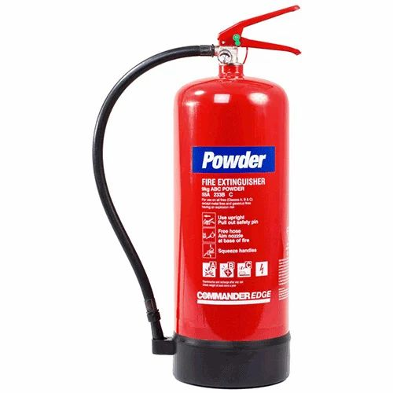Fire Extinguisher 6kg DCP DRY CHEMICAL POWDER (DCP)
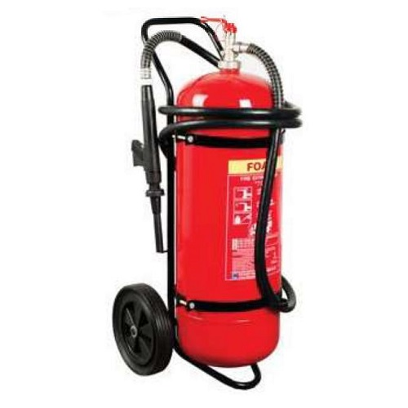 Fire Extinguisher 25 kg Trolly DCP

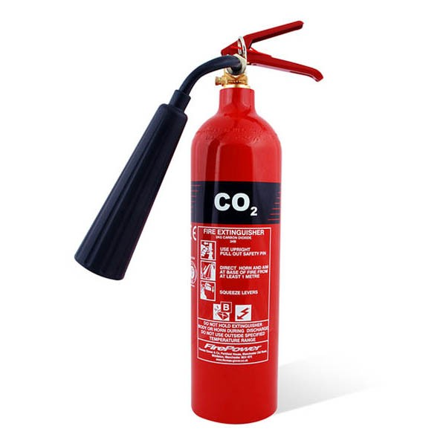 Fire Extinguisher 2 kg co2

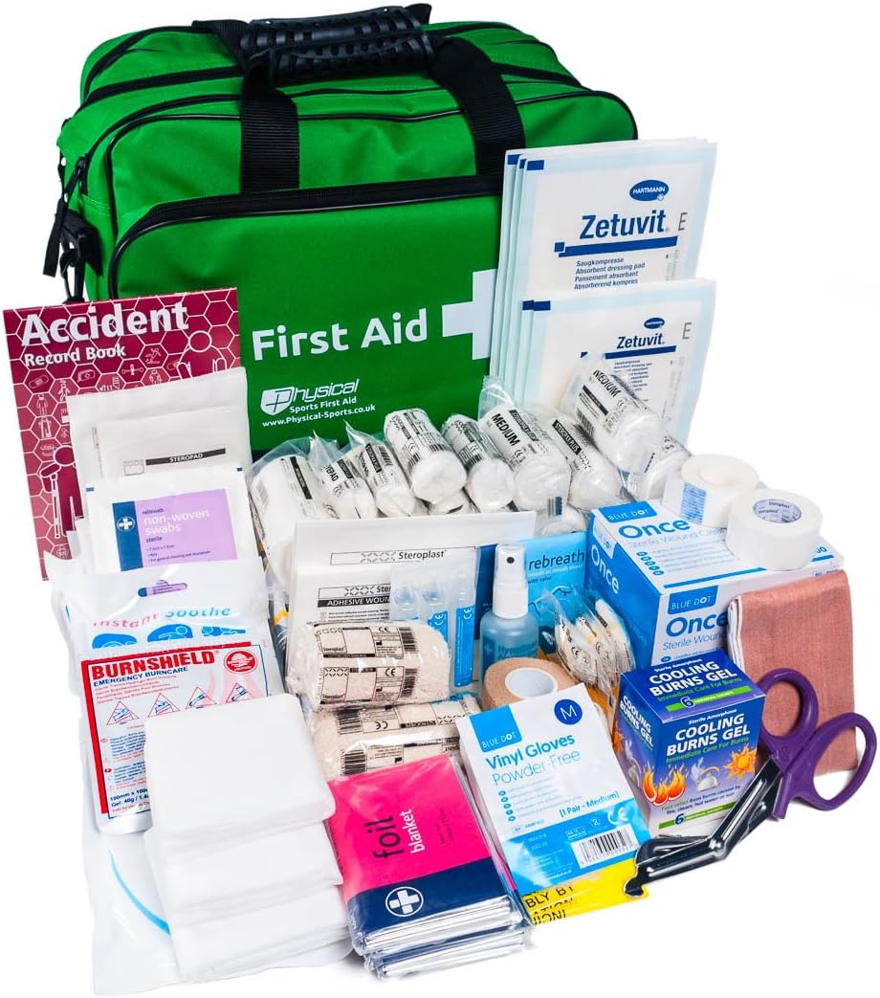 First Aid Kit 100 person

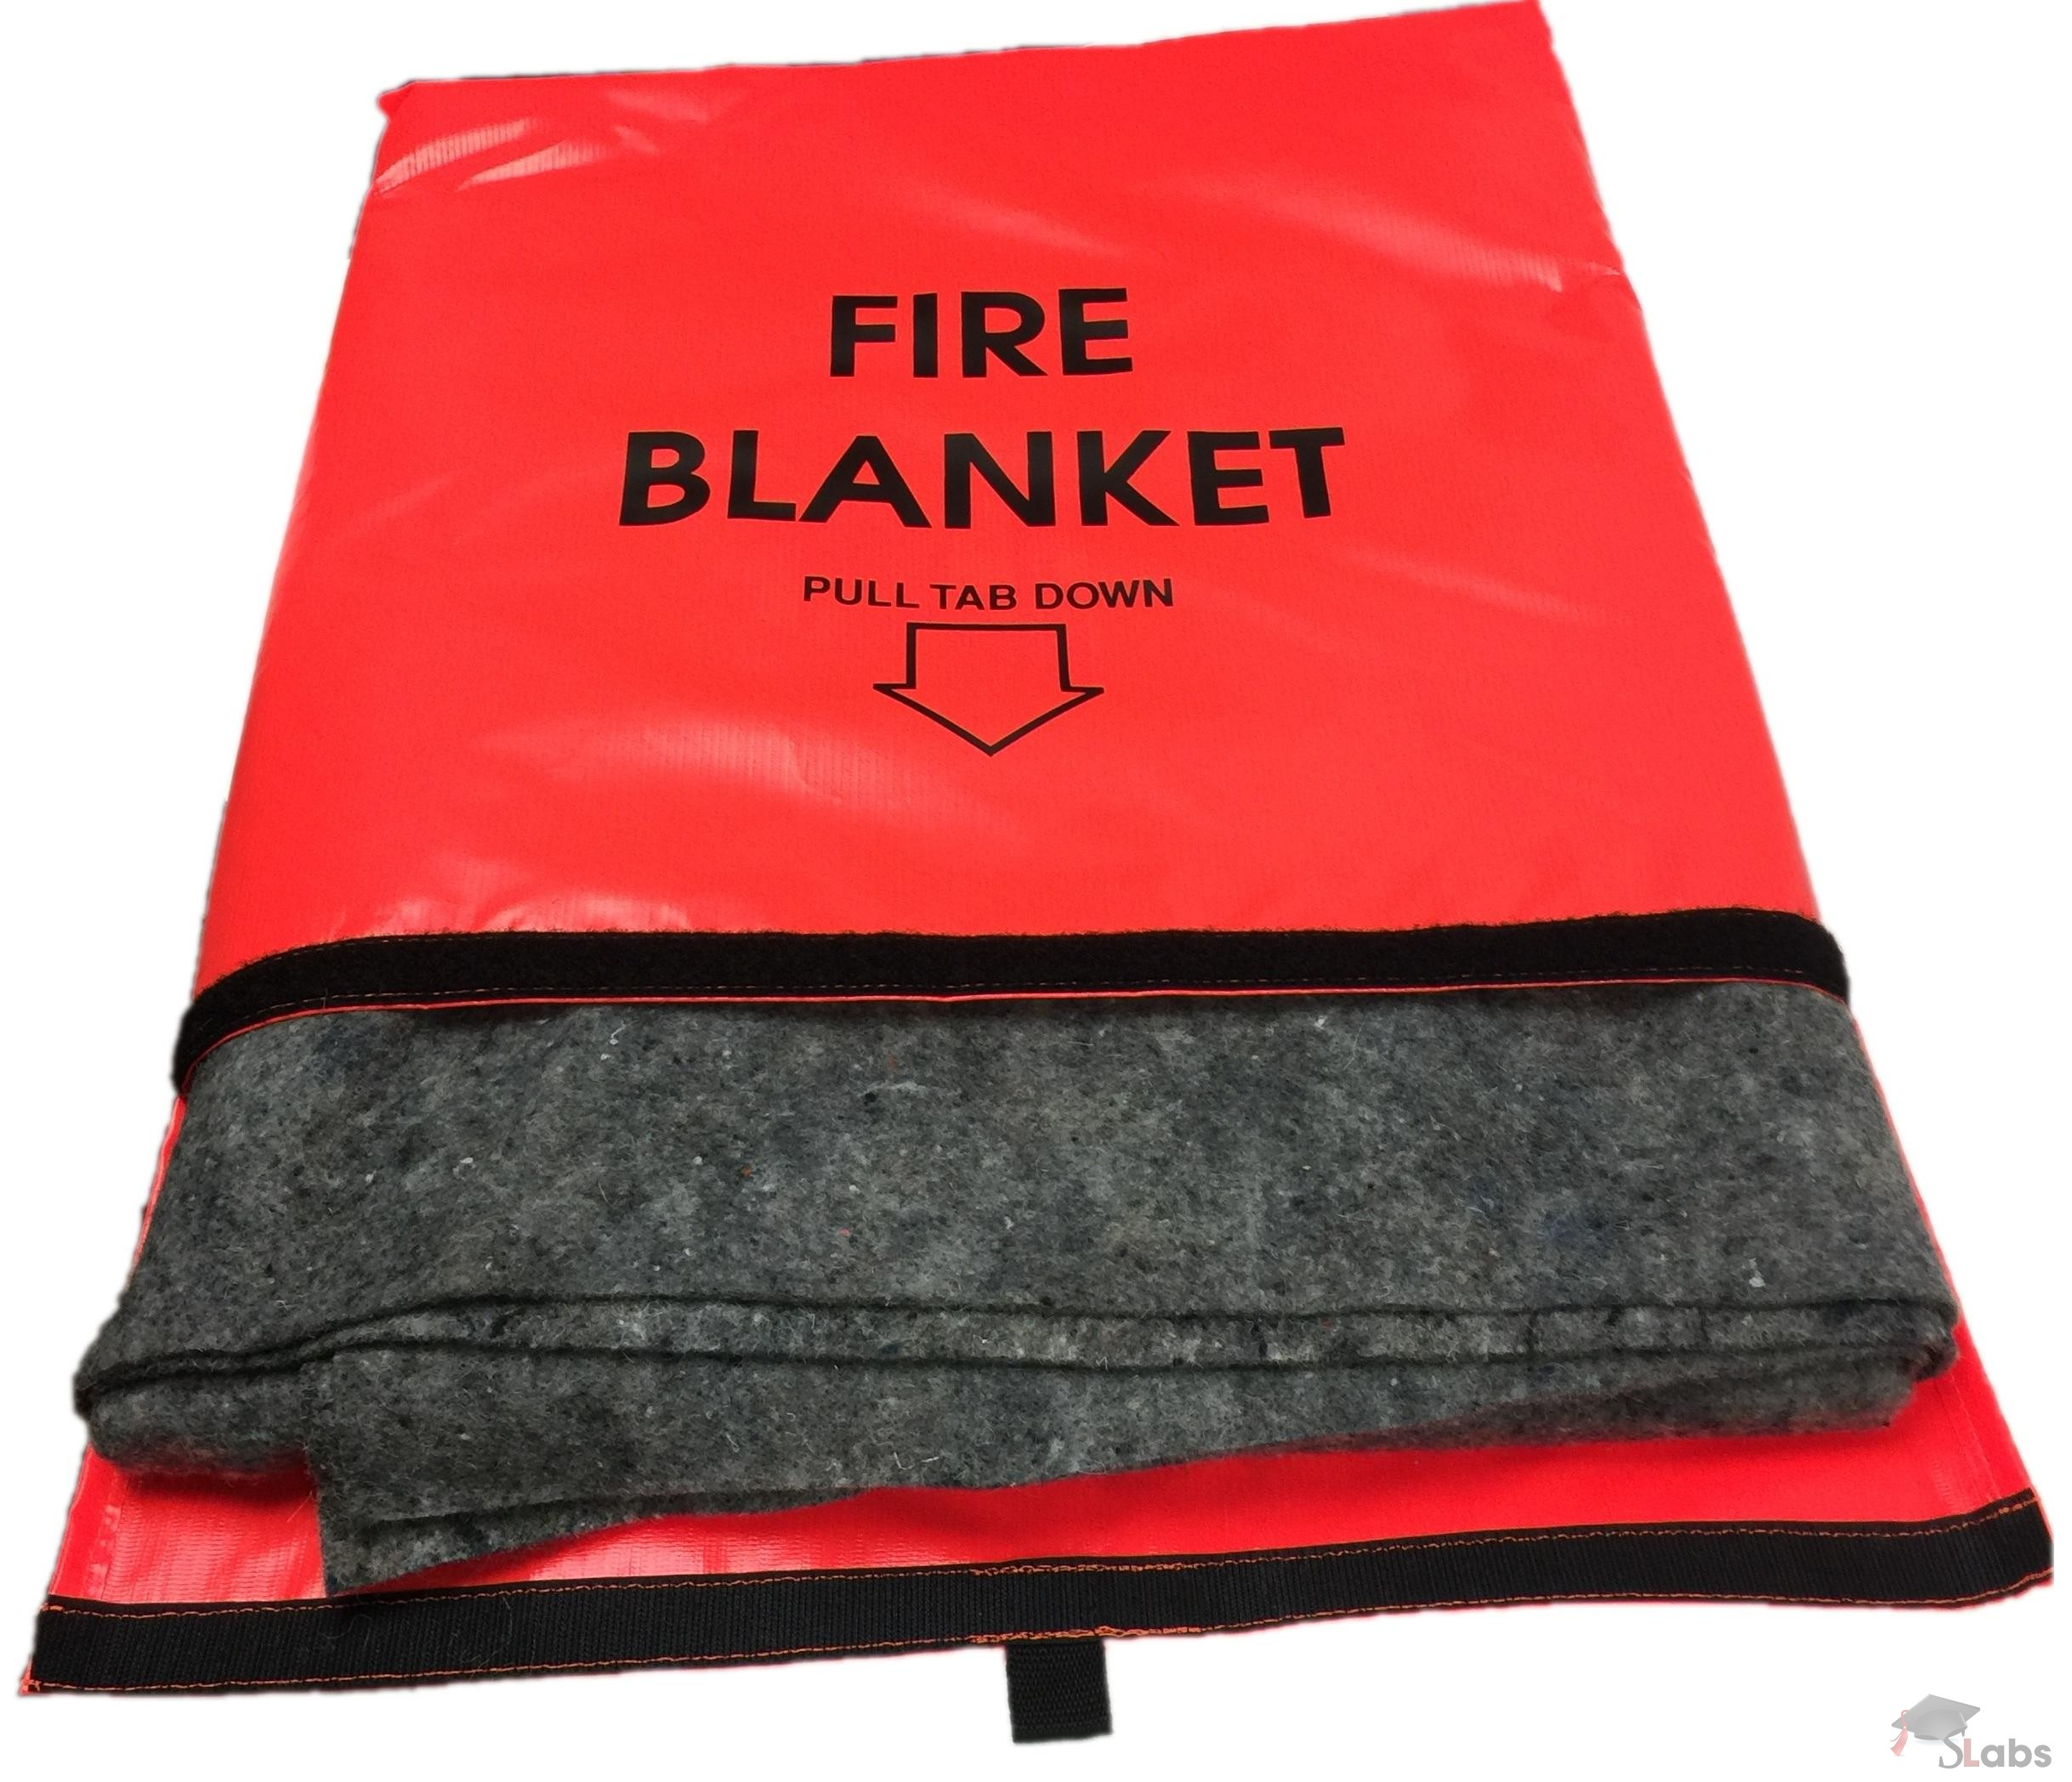 Fire Blanket

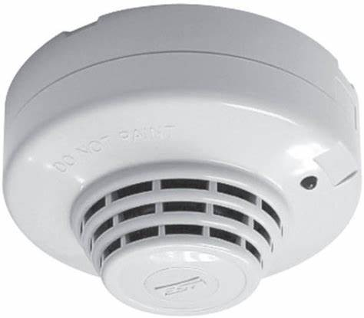 Smoke Detector

Ethical Standards Declaration for all Supply, Service and Works Contractors

We, the undersigned, (‘we’, ‘our’ or ‘us’) CONSIDERING THAT:
FIRST, we are bidding for, or entering into, a contract with the Norwegian Refugee Council (NRC) to supply goods, services or works to NRC (‘the Contract’).
SECOND, we understand that as a humanitarian organisation, NRC expects its suppliers and contractors to have high ethical standards.
THIRD, we understand that NRC therefore needs us to confirm that we adhere to the required ethical standards (‘the ethical standards’) by signing this declaration (‘the Declaration’).
THEREFORE, we DO HEREBY DECLARE as follows:

- Declaration concerning compliance with applicable laws and these ethical standards
We declare that we shall:
- Meet the ethical standards in this declaration (‘ethical standards’)
- Ensure that any party representing us, including but not limited to:
• board members
• directors
• employees
• contractors or sub-contractors, and their employees
• consultants and sub-consultants, and their employees;
• other legal representatives
(‘our Representatives’) are aware of and comply with these ethical standards.

In the event that we, or our Representatives, do not meet the ethical standards at present, we shall:
- Explain to NRC in what way we do not currently meet the ethical standards
- Agree a plan and timeline with NRC to implement changes that allow us to meet the ethical standards
- Provide regular updates to NRC on the implementation plan.

- Declaration concerning status
We hereby declare that neither we, nor to the best if our knowledge our Representatives, are in any of the following situations:

  - Have made an offer, payment, consideration or benefit of any kind, which constitutes illegal or corrupt practice, directly or indirectly, as an inducement or reward in relation to the tendering, awarding or execution of the Contract.
  - Are involved in any form of fraud, corruption, collusion, coercive practice, bribery, involvement in a criminal organisation or other illegal activity
  - Are insolvent, in receivership, bankrupt, or being wound up
  - Have suspended activities
  - Are subject to legal proceedings related to 2.1
  - Have at any time been found guilty and sentenced by a court, whether in the country of employment or abroad, for a criminal offence in respect of children or vulnerable adults
  - Are engaged in:
• terrorism or the material support of terrorism
• the sale or manufacture, either directly or indirectly, of anti-personnel mines or any components produced primarily for the operation thereof
• the sale or manufacture, either directly or indirectly, of weapons
• the production of alcohol, tobacco, or pornography.

- Declaration concerning Conflicts of Interest
We declare that neither we nor, to the best of our knowledge, our Representatives have an undisclosed conflict of interest with NRC.
Where any potential conflict of interest exists between our Representatives and NRC or any NRC staff member, we shall notify NRC in writing of the potential conflict. NRC shall then determine whether action is required.
A conflict of interest can be due to a relationship with an NRC staff member such as family or friends.
We understand that if we fail to report a potential conflict of interest and are later found to have a conflict of interest, we may be removed from the NRC vendor database.

- Declaration concerning compliance with national law
We declare that we and, to the best of our knowledge, our Representatives:
  - comply with all applicable laws and regulations in effect in the country or countries where the Contract will be carried out.
  - comply with all applicable export laws concerning the country or countries where the Contract will be carried out.
  - are registered with the relevant government authority with regard to taxation for the duration of the Contract.
  - pay taxes according to all applicable national laws and regulations for the duration of the Contract.

- Declaration concerning compliance with labour standards
We declare that we and, to the best of our knowledge, our Representatives:
We declare that we and, to the best of our knowledge, our Representatives comply with applicable national labour law standards and the International Labour Organisation Declaration on Fundamental Principles and Rights at Work.
Specifically, we declare that we and, to the best of our knowledge, our Representatives comply with the following minimum labour standards:

  - Working Conditions
- All workers receive a contract of employment that is written in a language they understand.
- All workers are free to leave after giving reasonable notice.
- All workers have the right to join or form trade unions of their own choosing and to bargain collectively.
- No worker is required to lodge ‘deposits’ or identity papers or immigration documents in order to obtain employment.
  - Wages and benefits
  - Wages and benefits paid for a standard working week meet, at a minimum, national legal standards or industry benchmark standards, whichever is higher. Wages are always sufficient to meet basic needs.
  - No deductions from wages are made as a disciplinary measure.
  - Working time
  - Working hours comply with national laws and benchmark industry standards, whichever affords greater protection. Whenever possible working hours do not exceed 48 hours per week (8 hours per day).
  - Workers are provided with at least one day off for every 7-day period.
  - Health and safety
  - Steps are taken to prevent accidents and injury to health arising out of, associated with, or occurring in, the course of work, by minimizing, so far as is reasonably practicable, the causes of hazards inherent in the working environment.
  - Workers receive regular and documented health and safety training, and such training is repeated for new workers.
  - Workers have access to clean toilet facilities and to potable water, and, if appropriate, sanitary facilities for food storage is provided.
  - Accommodation, where provided, is clean, safe and adequately ventilated.
  - Discrimination and abuse
  - No worker is forced, bonded or an involuntary prison worker.
  - There is no discrimination at the workplace based on ethnic background, religion, age, disability, gender, marital status, sexual orientation, union membership or political affiliation.
  - Measures are in place to protect workers from sexually intrusive, threatening, insulting or exploitative behaviour, and from discrimination or termination of employment on unjustifiable grounds, e.g. marriage, pregnancy, parenthood or HIV status.
  - Physical abuse or punishment, or threats of physical abuse, sexual or other harassment and verbal abuse, as well as other forms of intimidation, are prohibited.
  - Persons under 18
- No persons under the age of 18 shall be engaged in work which is hazardous to their health or safety, including night work.
- The working hours and nature of work of any worker who is under the age of 18 shall not interfere with their opportunity to complete his or her education.

- Declaration concerning the environmental standards
We declare that we and, to the best of our knowledge, our Representatives comply with applicable national environmental law standards and with international environmental standards, to the greatest extent possible.
Specifically, we declare that we and, to the best of our knowledge, our Representatives adhere to the following standards:
  - We respect national and international environmental legislation and regulation.
  - We ensure that production and extraction of raw materials for production does not contribute to the destruction of the resources and income base for marginalised populations, such as in claiming large land areas or other natural resources on which these populations are dependent.
  - We take environmental measures into consideration throughout the production and distribution chain ranging from the production of raw material to the consumer sale. This includes reasonable steps to minimise negative environmental impacts (e.g. emissions, water usage, waste) and to use - where possible - sustainable resources. Local, regional and global environmental aspects shall be considered. The local environment at the production site will not be exploited or degraded by pollution and waste.
  - We carefully manage hazardous chemicals and other substances in accordance with documented safety procedures.

- Declaration concerning protection from sexual exploitation and abuse
We and, to the best of our knowledge, our Representatives comply with international standards related to protection from sexual exploitation and abuse (PSEA) and sexual harassment.
Specifically, we declare that we and, to the best of our knowledge, our Representatives adhere to the following standards:
  - We take sexual misconduct seriously and ensure that any employee found to have carried out sexual misconduct will be subject to disciplinary action.
  - We will ensure, that none of our employees engage in any sexual activity with persons (adult or child) in relation with this contract regardless of the age of majority or consent locally.
  - We will ensure that none of our employees produce, procure, distribute or use sexually explicit material in any activities under the Contract or on any sites used under the Contract.
  - We will ensure that none of our employees will exchange money, employment, goods or services for sex, including sexual favours or other forms of humiliating, degrading, or exploitative behaviour. This prohibition extends to any use of sex trade workers. If any sexual misconduct is found to have taken place, such employees face disciplinary action.
  - We shall report any incident or complaint of sexual misconduct or child abuse related to the activities carried out under the Contract through NRC’s PSEA and Safeguarding Unit at psea@nrc.no.
  - We shall report any known or reported sexual relationship between our employees and NRC staff to NRC.

- Declaration concerning protection of children
We declare that neither we nor, to the best of our knowledge, our Representatives are engaged in any practice inconsistent with the rights set forth in the Convention on the Rights of the Child. We commit to upholding international and national laws and policies regarding child safeguarding.
Specifically, we declare that we and, to the best of our knowledge, our Representatives adhere to the following standards:
  - We support and protect the complainant, survivors and witnesses of any raised incidents or complaints of sexual misconduct or child abuse.
  - We will ensure, that our employees will not abuse or exploit children or act in a manner that may place a child at risk of harm.
  - We will ensure that our employees are not left alone with children.
  - We will ensure our employees will not ask children for personal contact details without a valid reason to do so.
  - We listen, to the best of our ability, to children’s views and opinions and treat boys and girls in a manner that is respectful of their rights and dignity during the performance of the Contract.
  - We shall report any suspicion of child safeguarding concerns through the Complaints and Feedback Mechanism, provided by the NRC contract focal point and at psea@nrc.no.

- Declaration concerning anti-human trafficking
We declare that neither we nor, to the best of our knowledge, our Representatives are engaged in trafficking in persons as defined in the protocol to Prevent, Suppress and Punish Trafficking in Persons or the UN Convention against Transnational Organized Crime.
Specifically, we declare that we and, to the best of our knowledge, our Representatives adhere to the following standards:
  - We do not solicit persons for the purpose of employment, or offer employment by means of materially false or fraudulent pretences, representations, or promises.
  - We do not charge employees recruitment fees.
  - We do not provide or arrange housing for employees that does not meet host country housing and safety standards.
  - We commit to report any suspected violations of this clause to NRC immediately.
  - We commit to make our Representatives aware of the trafficking related prohibitions outlined above and share the Global Human Trafficking Hotline Information with them (1-844-888-FREE, help@befree.org).

- General
We understand that:
  - The Declaration will be kept on file for a period of 10 years.
  - The Declaration will be updated every year or more often as appropriate.
  - We must inform NRC immediately in the event that there is a change to the Declaration.
  - NRC may perform checks to verify that the ethical standards are adhered to and shall be granted reasonable access to our premises and to our documentation, computer systems etc, in order to be allowed to do so.
  - In the event that NRC deem that we fail to meet or are not taking appropriate steps to meet, the ethical standards, NRC may immediately terminate any and all contracts and agreements we have with them and at no cost to NRC.

- Requirement to notify NRC
We shall immediately notify NRC through the Complaints and Feedback Mechanism, provided by the NRC contract focal point if:
  - Any allegations of alleged corruption, sexual exploitation or abuse, or child abuse are made against us or, to the best our knowledge, our Representatives, during the Contract, whether relating to the Contract or not.
  - Any allegations are made, or any changes occur, in relation to any of the declarations made herein

Signed on our behalf as follows:
Signature
Name
Position
Date
Place

